**6.Experiments based on list and its operation**

**Ex. No. : 6.1 Date: 13/05/2024**

**Register No.: 231801047 Name: HANNAH JAMES**

Write a Python program to check if a given list is strictly increasing or not. Moreover, If removing only one element from the list results in a strictly increasing list, we still consider the list true

**Input:**

n : Number of elements

List1: List of values

Output

Print "True" if list is strictly increasing or decreasing else print "False"

Sample Test Case

Input

7

1

2

3

0

4

5

6

**Output**

True

**PROGRAM:**

n=int(input(""))

l1=[int(input()) for _ in range(n)]

def is_s_i(lst):

c=0

for i in range(1, len(lst)):

if lst[i] < lst[i-1]:

c +=1

if c > 1:

return False

if i==1 or lst[i] > lst[i-2]:

continue

elif i<len(lst)-1 and lst[i+1]>lst[i-1]:

continue

else:

return False

return True

def is_s_d(lst):

r_lst=lst[::-1]

return is_s_d(r_l)

if is_s_i(l1) or is_s_d(l1):

print("True")

else:

print("False")

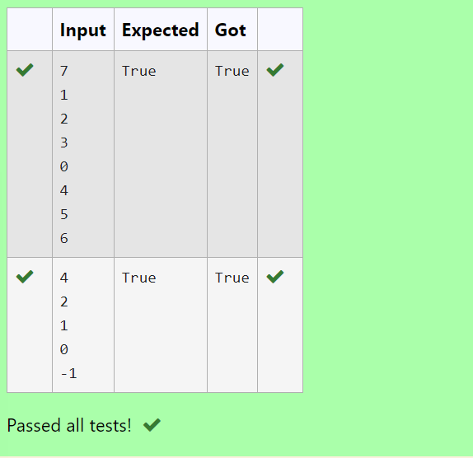

**Ex. No. : 6.2 Date: 13/05/2024**

**Register No.: 231801047 Name: HANNAH JAMES**

Find the intersection of two sorted arrays.

OR in other words,

Given 2 sorted arrays, find all the elements which occur in both the arrays.

**Input Format**

The first line contains T, the number of test cases. Following T lines contain:

1.      Line 1 contains N1, followed by N1 integers of the first array

2.      Line 2 contains N2, followed by N2 integers of the second array

**Output Format**

The intersection of the arrays in a single line

**Example**

**Input**:

1

3 10 17 57

6 2 7 10 15 57 246

**Output:**

10 57

**Input:**

1

7

1

2

3

3

4

5

6

2

1

6

**Output:**

1 6

**For example:**

| **Input** | **Result** |
| --- | --- |
| 1  3  10  17  57  6  2  7  10  15  57  246 | 10 57 |
| 1  7  1  2  3  3  4  5  6  2  1  6 | 1 6 |

**PROGRAM:**

def intersection(l1,l2):

l3=[value for value in l1 if value in l2]

return l3

n=int(input())

for i in range(0,n):

s1=int(input())

l1=[]

for x in range (0,s1):

e1=int(input())

l1.append(e1)

s2=int(input())

l2=[]

for y in range (0,s2):

e2=int(input())

l2.append(e2)

print(*intersection (l1,l2))

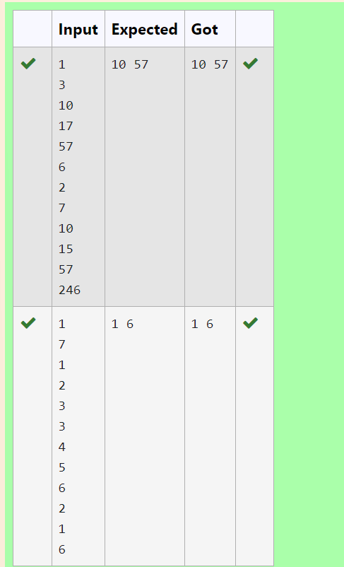

**Ex. No. : 6.3 Date: 13/05/2024**

**Register No.: 231801047 Name: HANNAH JAMES**

Program to print all the distinct elements in an array. Distinct elements are nothing but the unique (non-duplicate) elements present in the given array.

Input Format:

First line take an Integer input from stdin which is array length n.

Second line take n Integers which is inputs of array.

Output Format:

Print the Distinct Elements in Array in single line which is space Separated

**Example Input:**

5

1

2

2

3

4

**Output:**

1 2 3 4

**Example Input:**

6

1

1

2

2

3

3

**Output:**

1 2 3

**For example:**

| **Input** | **Result** |
| --- | --- |
| 5  1  2  2  3  4 | 1 2 3 4 |
| 6  1  1  2  2  3  3 | 1 2 3 |

**PROGRAM:**

def d_e (a):

dt_s = set(a)

d_l = list(d_s)

d_l.sort()

return d_l

n = int(input())

a = [int(input()) for _ in range(n)]

distinct = d_e (a)

print(" ".join(map(str, distinct)))

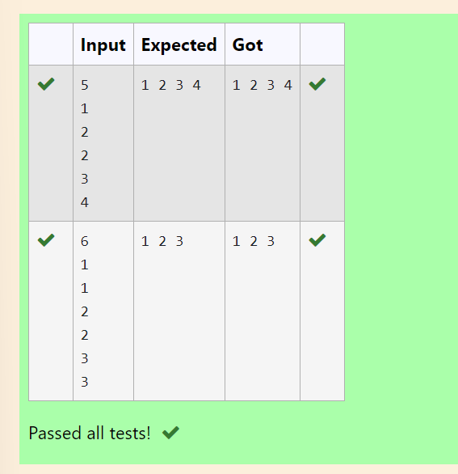

**Ex. No. : 6.4 Date: 13/05/2024**

**Register No.: 231801047 Name: HANNAH JAMES**

Given an array of numbers, find the index of the smallest array element (the pivot), for which the sums of all elements to the left and to the right are equal. The array may not be reordered.

**Example**

arr=[1,2,3,4,6]

·         the sum of the first three elements, 1+2+3=6. The value of the last element is 6.

·         Using zero based indexing, arr[3]=4 is the pivot between the two subarrays.

·         The index of the pivot is 3.

**Constraints**

·         3 ≤ n ≤ 105

·         1 ≤ arr[i] ≤ 2 × 104, where 0 ≤ i < n

·         It is guaranteed that a solution always exists.

The first line contains an integer n, the size of the array arr.

Each of the next n lines contains an integer, arr[i], where 0 ≤ i < n.

**Sample Case 0**

**Sample Input 0**

4

1

2

3

3

**Sample Output 0**

2

**Explanation 0**

·         The sum of the first two elements, 1+2=3. The value of the last element is 3.

·         Using zero based indexing, arr[2]=3 is the pivot between the two subarrays.

·         The index of the pivot is 2.

Sample Case 1

Sample Input 1

3

1

2

1

**Sample Output 1**

1

**Explanation 1**

·         The first and last elements are equal to 1.

·         Using zero based indexing, arr[1]=2 is the pivot between the two subarrays.

·         The index of the pivot is 1.

**For example:**

| **Input** | **Result** |
| --- | --- |
| 4  1  2  3  3 | 2 |
| 3  1  2  1 | 1 |

**PROGRAM:**

def f_p_i (a):

t_s = sum(a)

l_s = 0

for i, num in enumerate(a):

t_s -= num

if l_s== t_s:

return i

l_s += num

return -1

n = int(input())

a= [int(input()) for _ in range(n)]

print(f_p_i(a))

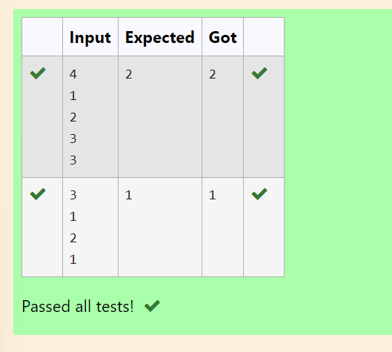

**Ex. No. : 6.5 Date: 13/05/2024**

**Register No.: 231801047 Name: HANNAH JAMES**

Given an array A of sorted integers and another non negative integer k, find if there exists 2 indices i and j such that A[i] - A[j] = k, i != j.

**Input Format**

1.      First line is number of test cases T. Following T lines contain:

2.      N, followed by N integers of the array

3.      The non-negative integer k

**Output format**

Print 1 if such a pair exists and 0 if it doesn’t.

Example

Input

1

3

1

3

5

4

Output:

1

Input

1

3

1

3

5

99

Output

0

**For example:**

| **Input** | **Result** |
| --- | --- |
| 1  3  1  3  5  4 | 1 |
| 1  3  1  3  5  99 | 0 |

**PROGRAM:**

t=int(input())

for i in range(0,t):

n=int(input())

l=[]

for j in range(0,n):

a=int(input())

l.append(a)

p=int(input())

for k in range(0,n):

c=0

for m in range(i+1,n):

if l[m]-l[k]==p:

c=1

print('1')

break

if c==1:

break

if c==0:

print('0')

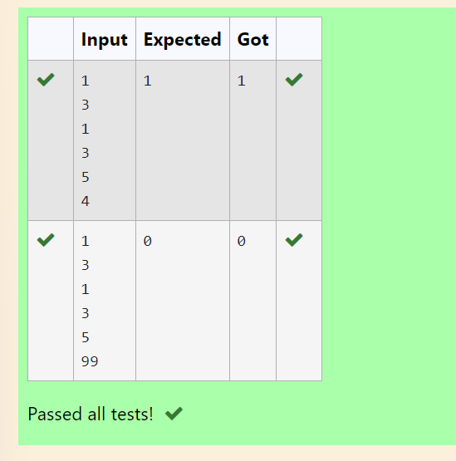

**Ex. No. : 6.6 Date: 13/05/2024**

**Register No.: 231801047 Name: HANNAH JAMES**

Write a program to print all the locations at which a particular element (taken as input) is found in a list and also print the total number of times it occurs in the list. The location starts from 1.

For example, if there are 4 elements in the array:

5

6

5

7

If the element to search is 5 then the output will be:

5 is present at location 1

5 is present at location 3

5 is present 2 times in the array.

Sample Test Cases

Test Case 1

Input

4

5

6

5

7

5

Output

5 is present at location 1.

5 is present at location 3.

5 is present 2 times in the array.

Test Case 2

Input

5

67

80

45

97

100

50

Output

50 is not present in the array.

**PROGRAM:**

n = int(input())

a = [int(input()) for _ in range(n)]

se = int(input())

l = []

c = 0

for i in range(n):

if a[i] == se:

l.append(i + 1)

c += 1

if c > 0:

for loc in l:

print(f"{se} is present at location {loc}.")

print(f"{se} is present {c} times in the array.")

else:

print(f"{se} is not present in the array.")

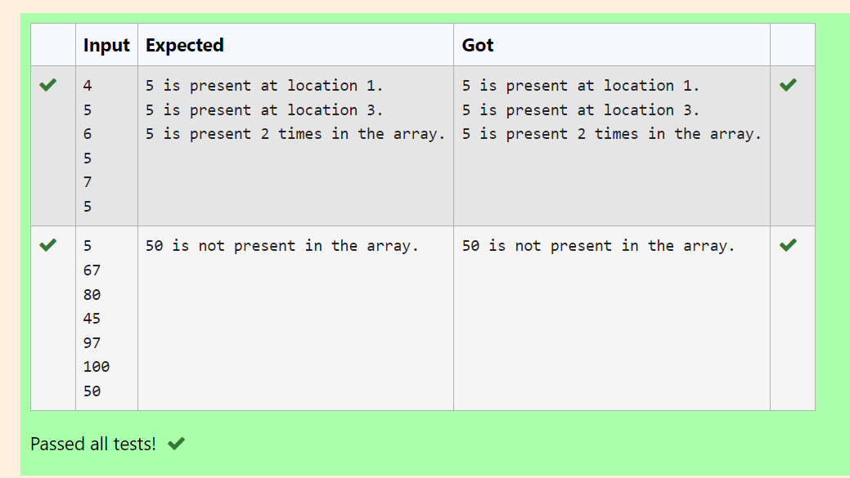

**Ex. No. : 6.7 Date: 13/05/2024**

**Register No.: 231801047 Name: HANNAH JAMES**

Output is a merged array without duplicates.

**Input Format**

N1 - no of elements in array 1

Array elements for array 1

N2 - no of elements in array 2

Array elements for array2

**Output Format**

Display the merged array

**Sample Input 1**

5

1

2

3

6

9

4

2

4

5

10

**Sample Output 1**

1 2 3 4 5 6 9 10

**PROGRAM:**

N1 = int(input().strip())

arr1 = set()

for _ in range(N1):

arr1.add(int(input().strip()))

N2 = int(input().strip())

arr2 = set()

for _ in range(N2):

arr2.add(int(input().strip()))

merged_array = sorted(arr1.union(arr2))

print(*merged_array)

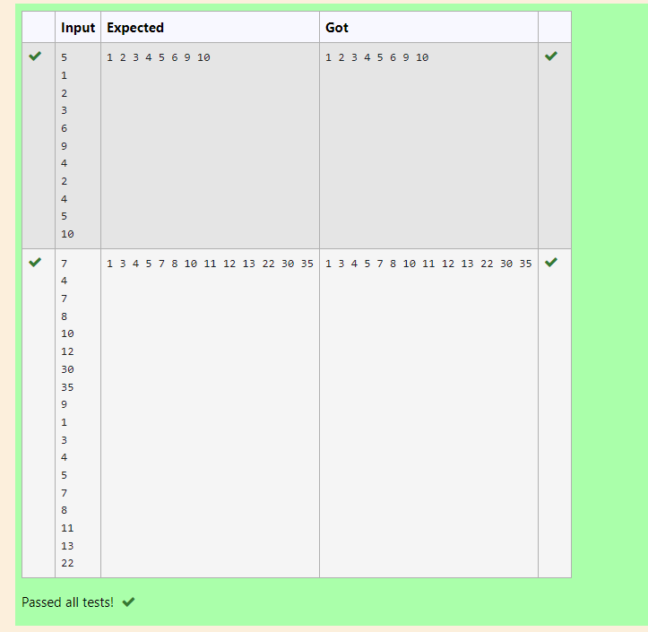

**Ex. No. : 6.8 Date: 13/05/2024**

**Register No.: 231801047 Name: HANNAH JAMES**

Complete the program to count frequency of each element of an array. Frequency of a particular element will be printed once.

Sample Test Cases

Test Case 1

Input

7

23

45

23

56

45

23

40

Output

23 occurs 3 times

45 occurs 2 times

56 occurs 1 times

40 occurs 1 times

**PROGRAM:**

n = int(input().strip())

arr = []

for _ in range(n):

arr.append(int(input().strip()))

f = {}

for num in arr:

if num in f:

f[num] += 1

else:

f[num] = 1

for num, freq in f.items():

print(f"{num} occurs {freq} times")

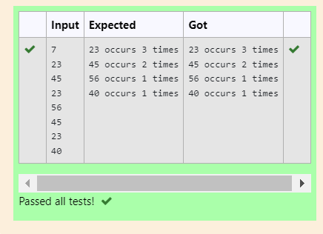

**Ex. No. : 6.9 Date: 13/05/2024**

**Register No.: 231801047 Name: HANNAH JAMES**

Consider a program to insert an element / item in the sorted array. Complete the logic by filling up required code in editable section. Consider an array of size 10. The eleventh item is the data is to be inserted.

Sample Test Cases

Test Case 1

Input

1

3

4

5

6

7

8

9

10

11

2

Output

ITEM to be inserted:2

After insertion array is:

1

2

3

4

5

6

7

8

9

10

11

Test Case 2

Input

11

22

33

55

66

77

88

99

110

120

44

Output

ITEM to be inserted:44

After insertion array is:

11

22

33

44

55

66

77

88

99

110

120

**PROGRAM:**

l=[]

for i in range(0,10):

e=int(input())

l.append(e)

a=int(input())

print("ITEM to be inserted:{:d}".format(a))

print("After insertion array is:")

l.append(a)

l.sort()

for j in range(0,11):

print(l[j])

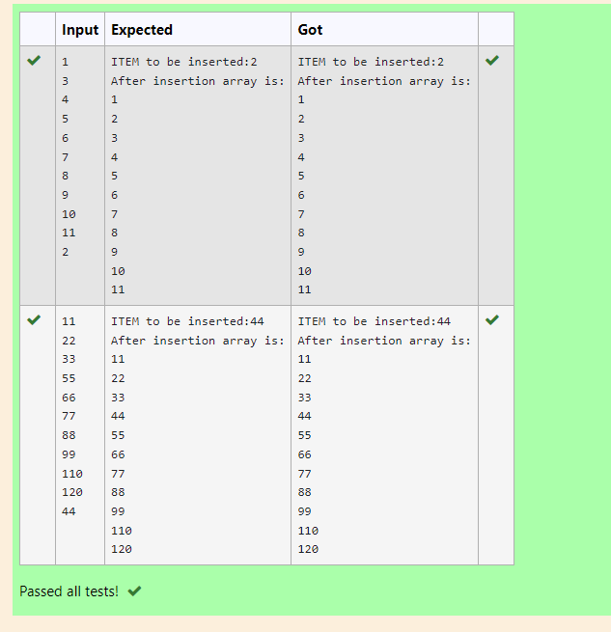

**Ex. No. : 6.10 Date: 13/05/2024**

**Register No.: 231801047 Name: HANNAH JAMES**

Given two lists A and B, and B is an anagram of A. B is an anagram of A means B is made by randomizing the order of the elements in A.

We want to find an *index mapping* P, from A to B. A mapping P[i] = j means the ith element in A appears in B at index j.

These lists A and B may contain duplicates. If there are multiple answers, output any of them.

For example, given

**Input**

5

12 28 46 32 50

50 12 32 46 28

**Output**

1 4 3 2 0

**Explanation**

A = [12, 28, 46, 32, 50]

B = [50, 12, 32, 46, 28]

We should return

[1, 4, 3, 2, 0]

as P[0] = 1 because the 0th element of A appears at B[1], and P[1] = 4 because the 1st element of A appears at B[4], and so on.

**Note:**

1. A, B have equal lengths in range [1, 100].
2. A[i], B[i] are integers in range [0, 10^5].

**PROGRAM:**

def index_mapping(A, B):

index_map = {num: i for i, num in enumerate(B)}

return ' '.join(str(index_map[num]) for num in A)

n = int(input())

A = list(map(int, input().split()))

B = list(map(int, input().split()))

print(index_mapping(A, B))

